**Octupan, Nicaragua**

Trócaire’s partner Octupan is located in Condega, one of the biggest municipalities in Nicaragua. Condega is in ‘They Dry Corridor’, the region most affected by drought in the country and therefore the poorest region of the country. Octupan has 10 staff. They promote technologies to save energies and agro ecology. They facilitate committees of women to plan actions to defend their rights

Most families in the region are farmers. Maize and beans are the main crops. Tomatoes are becoming more popular. Tobacco is also a popular crop. It creates lots of jobs, but it is a threat for the environment. Some people from the region travel to Esteli to work in the tobacco factories and return at night. It is mainly women who do this work as their hands are small. The chemicals are causing bad health issues. The tobacco companies are using huge amounts of water, taking it from the local communities. Some migrate to Honduras at from November to March to find work in the coffee plantations there. The government had been blamed for deforestation in the region.

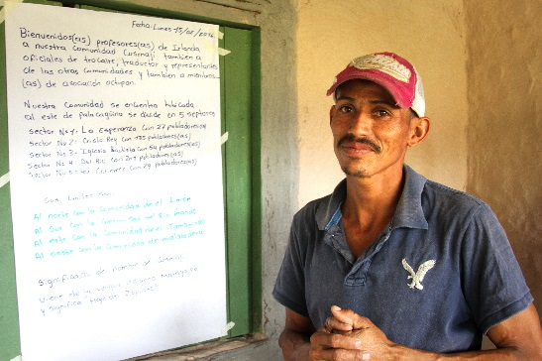 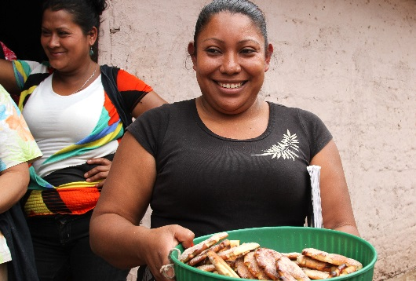

**Joel Montenegro (33 years) & Mariela Pastran (28 years)**

“In the 80’s/90’s growth was good. After deforestation increased, production decreased. Production decreased also because of droughts and hurricanes. When it rains, it rains heavy. When there is too much water, crops are damaged. Because of this many people migrate to other parts or other countries.” (Joel)

“For those who have chosen to stay, it was great to have support from Octupan. It allowed them to adapt to changes in the environment and taught them to manage water. It is important to use the water they have more efficiently. We gained knowledge and skills and the value in using agro ecological techniques.” (Joel)

“We are a low income family so we have no resources to buy fertilisers. Therefore it has been great to learn how to use our local resources better. Octupan provides technical assistance, teaching us how to diversify and how to protect the environment which provides food security and a healthy diet.” (Joel)

“We now grow carrots, coriander, tomatoes, onions, sweet peppers, cucumber and pumpkins all using organic techniques. We grow passion fruits, oranges and mangoes. We grow everything in terraces, which is a technique for conserving the soil.” (Mariela)

“Before we only grew corn, beans and sorghum. Now we eat what we grow but we can also sell produce to generate income.” (Joel)

“We do not use machinery, it is all man power. But we do use a small pump with fuel to bring water from the river [for irrigating the crops]. We have a dripping irrigation system. A more efficient use of the water. We have a well for domestic use.” (Joel)

“The oven Octupan gave us is a big benefit to us women. Before we used big pieces of wood to operate our oven. We needed three loads. Now we use one load of smaller wood. The smoke goes out our chimney so it doesn’t affect our health. Before we needed help from the men. Now we can do the work ourselves. It is much easier and faster to use. I sell the bread that I make. This type of bread sells two/three times higher because it is better quality. My neighbour uses the oven too. We also use the oven to make pastries, cakes, chicken and coffee.” (Mariela)

“Octupan gave us a water filter. It purifies the water. I carry the container on my head from the well once a day”

The well is 10metres deep. Before we had to walk to the river, now we use the well for domestic use. I excavated the well myself. Octupan helped with materials. This water never dries up, even in the dry season. It took me one month to build.” (Joel)

We make compost based on organic materials, leaves, yeast, sorghum, alcohol, and poo of cattle, black and red soil. We have a formula with hose ingredients. We do it in layers, mix it and pour water on it and cover it in plastic. Every day for 10 days we mix it. Then it is ready” (Joel)